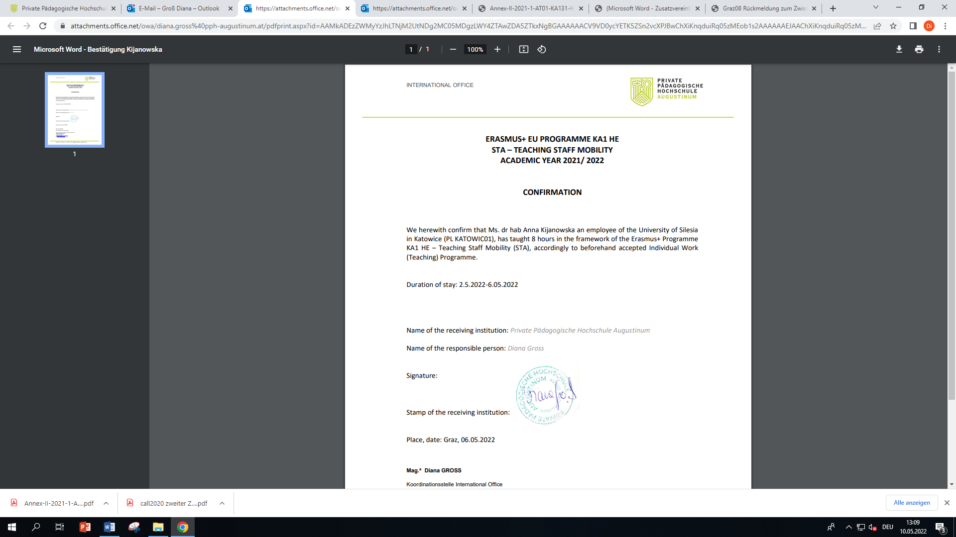

LETTER OF CONFIRMATION
Teaching Assignment

ERASMUS+ KA131

TEACHER
Family name:
First name:

SENDING INSTITUTION
Country: | Austria
Name of sending institution: | Private Pädagogische Hochschule in Graz
Erasmus code of sending institution: | A GRAZ08
Faculty/Department:

RECEIVING INSTITUTION
Country:
Name of receiving institution:
Erasmus code of receiving institution:
Faculty/Department:

This is to certify that the teacher undertook the TEACHING Assignment under the Erasmus+ programme KA 131 at our institution

from of the academic year 2022/23.

Thank you very much for the kind visit and good cooperation.

Place and date:
Signature and stamp of the responsible person

